**Oracle – Query result Assignment**

**Database Name:** Chinook

**Query 1:**

select sum(Total) as TotalSales from CHINOOK.INVOICE;

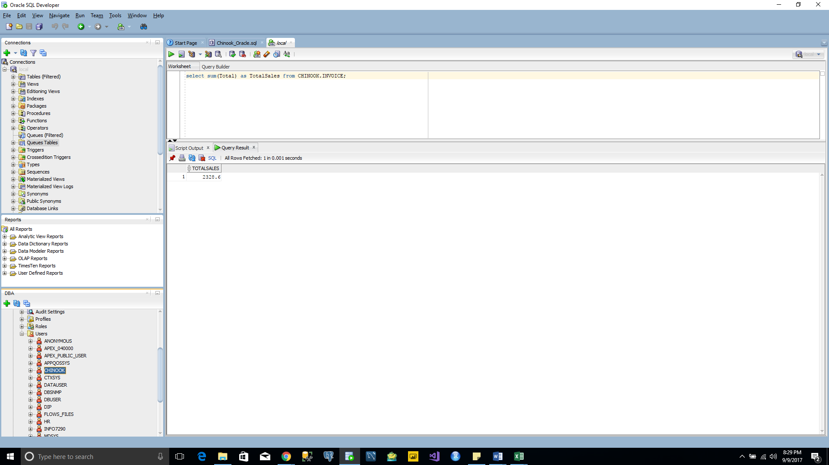

**Query 2:**

select billingcountry as CountryName, sum(Total) as TotalSales, DENSE_RANK() over(order by sum(Total) desc) as CountryRank from CHINOOK.INVOICE group by billingcountry;

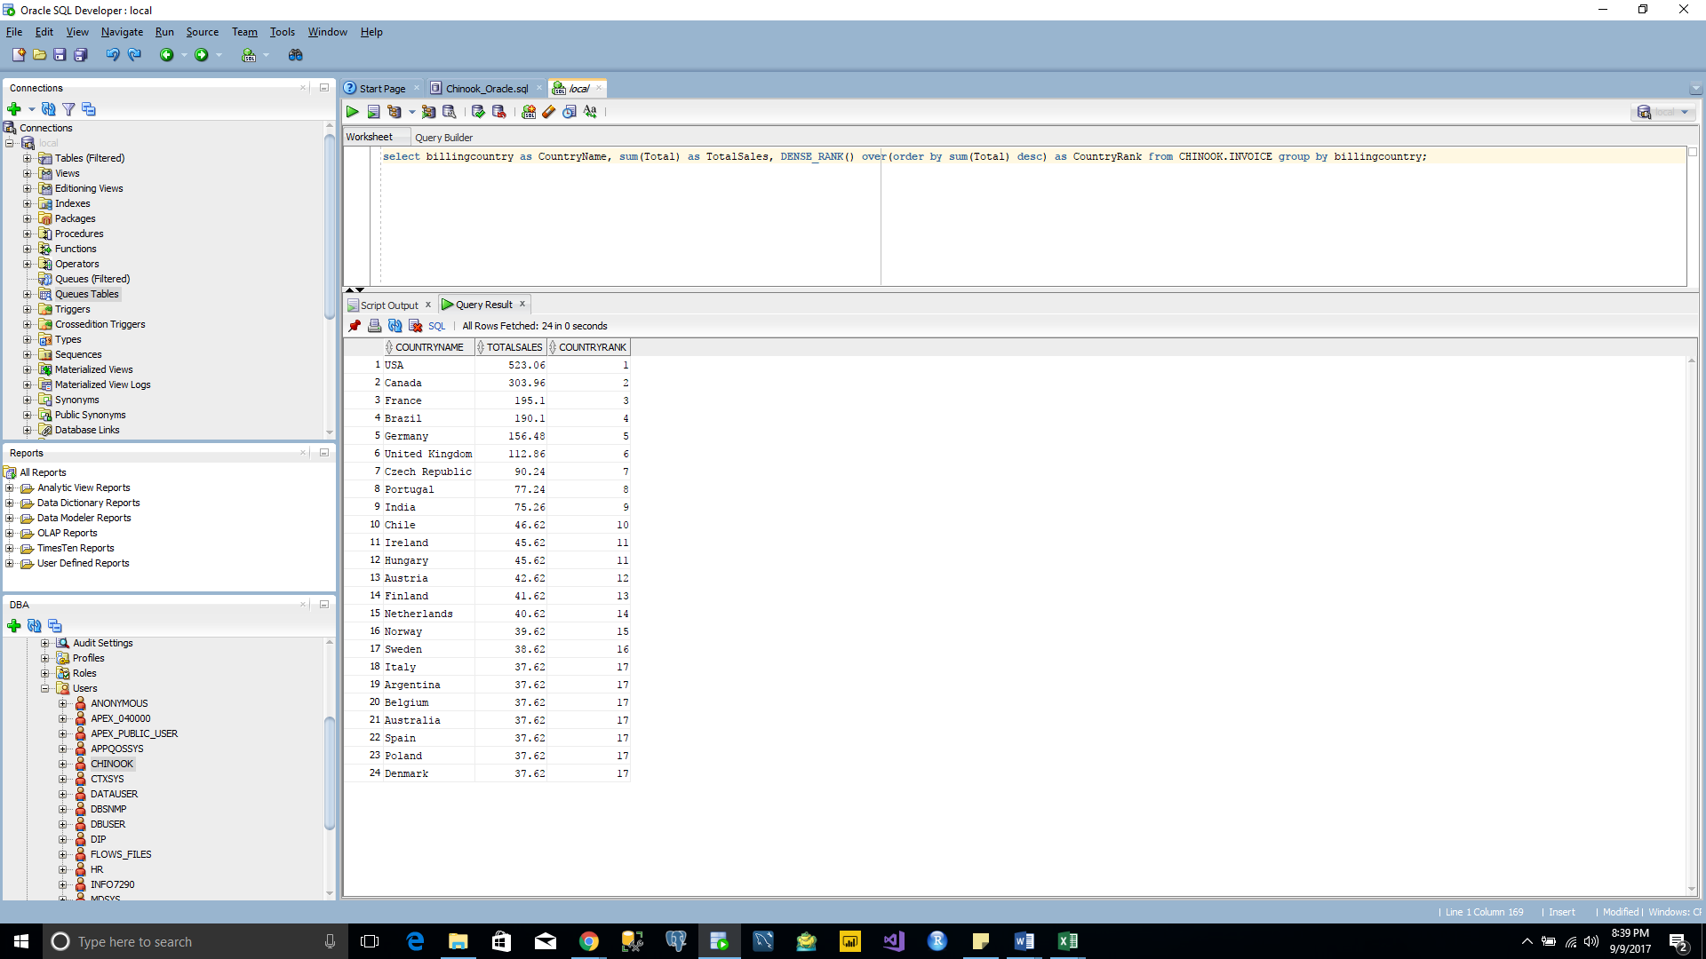

**Query 3:**

select billingcountry as Country, billingstate as State, billingcity as City, sum(Total) as TotalSales from chinook.Invoice group by billingcountry,billingstate,billingcity order by sum(Total) desc;

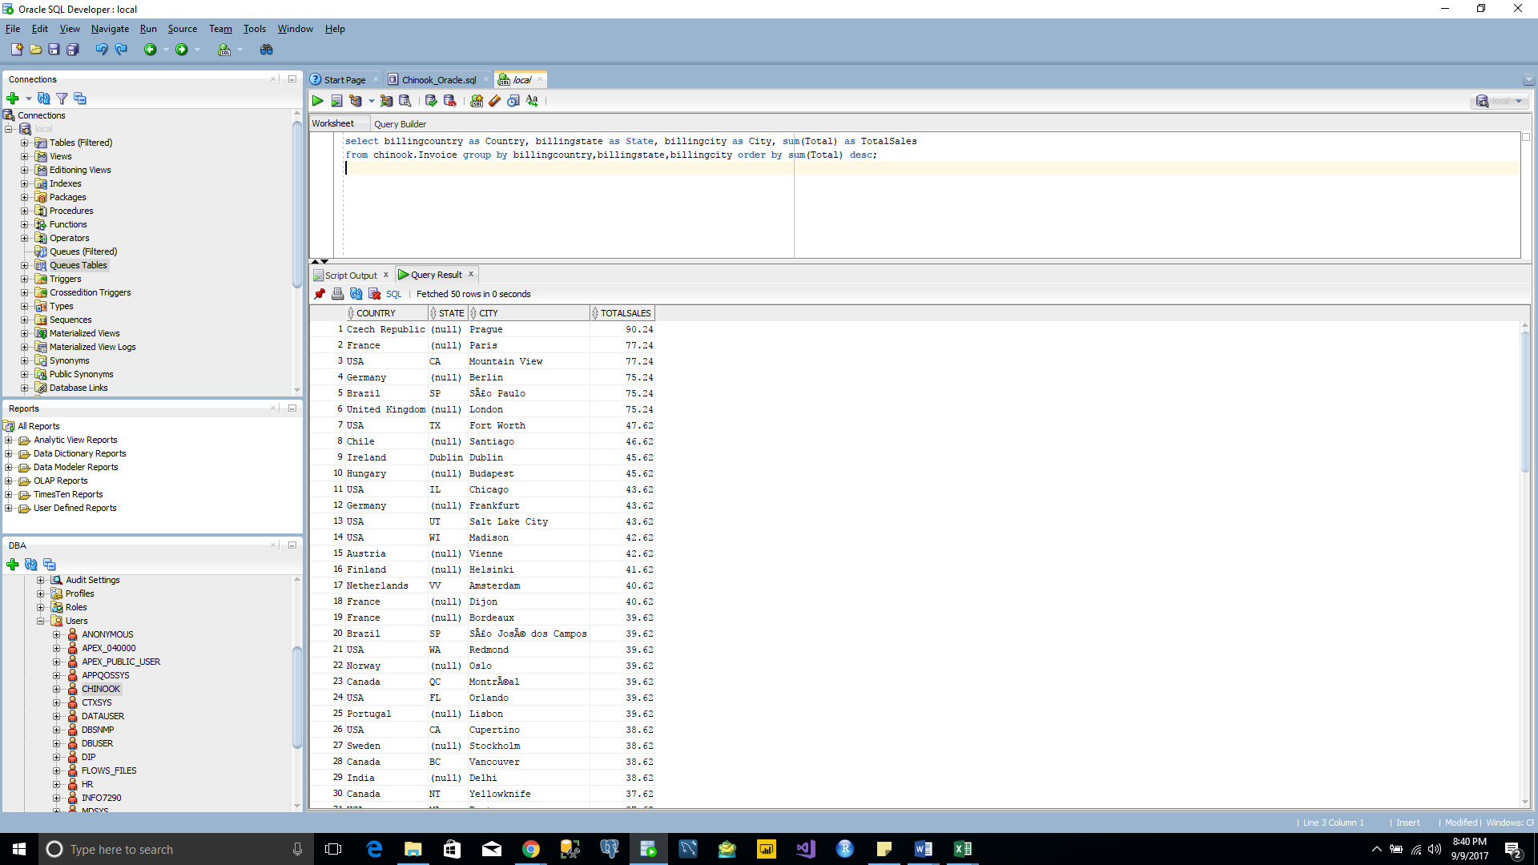

**Query 4:**

select concat(cus.firstname || ' ', cus.lastname) as CustomerName, sum(inv.Total) as TotalSales, DENSE_RANK() over (order by sum(inv.Total) desc) as CustomerRank

from CHINOOK.INVOICE inv inner join CHINOOK.CUSTOMER cus on inv.CUSTOMERID = cus.CUSTOMERID group by concat(cus.firstname || ' ', cus.lastname);

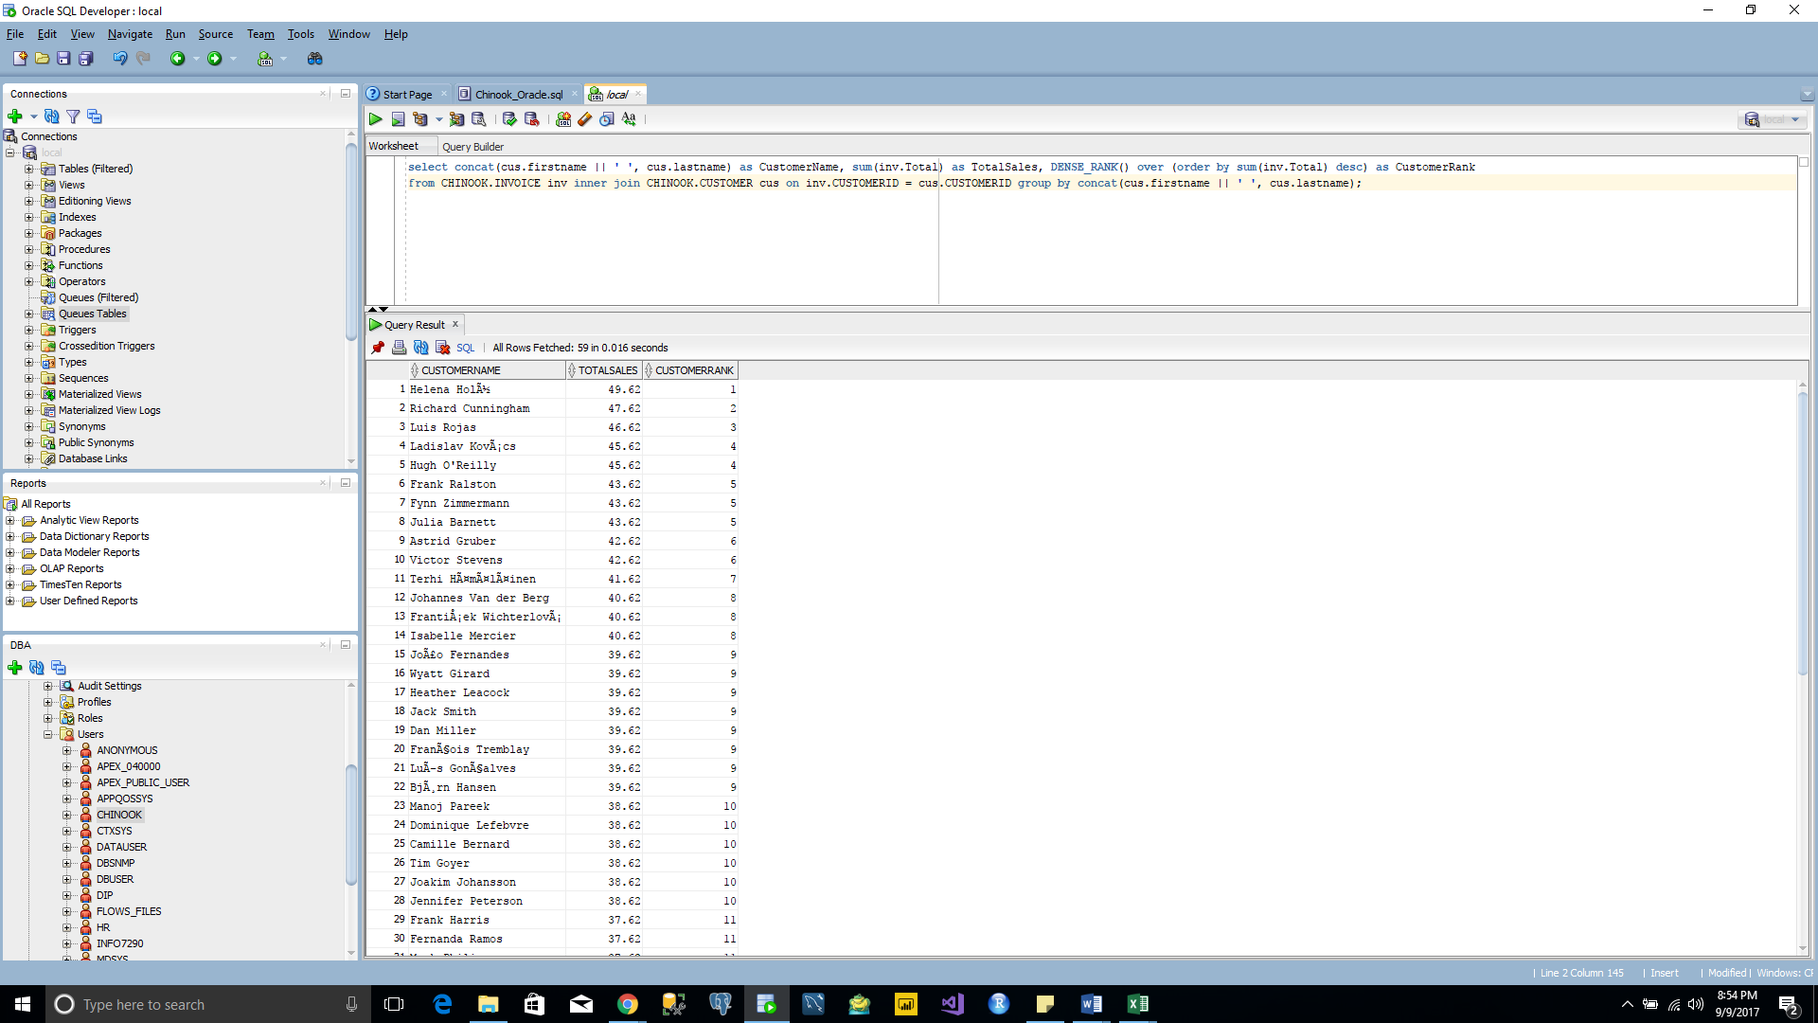

**Query 5:**

select ar.name as ArtistName, sum(iv.Total) as TotalSales, DENSE_RANK() over(order by sum(iv.total) desc) as ArtistRank from chinook.Invoice iv inner join chinook.InvoiceLine il on iv.InvoiceId=il.InvoiceId inner join chinook.Track tr on il.TrackId=tr.TrackId inner join chinook.Album al on tr.AlbumId=al.AlbumId inner join chinook.Artist ar on al.ArtistId=ar.ArtistId group by ar.name order by sum(iv.Total) desc;

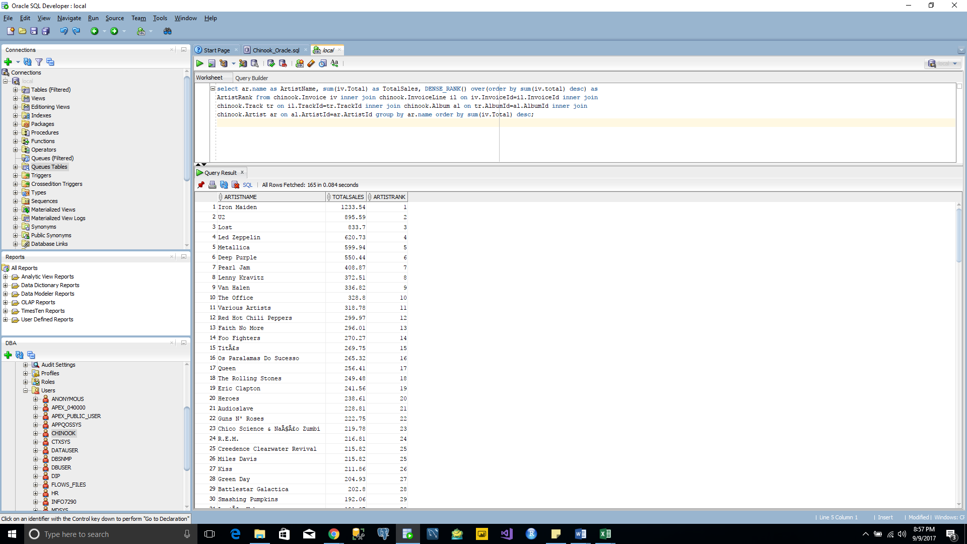

**Query 6:**

select ar.name as ArtistName, al.Title as AlbumName, sum(iv.Total) as TotalSales from chinook.Invoice iv inner join chinook.InvoiceLine il on iv.InvoiceId=il.InvoiceId inner join chinook.Track tr on il.TrackId=tr.TrackId inner join chinook.Album al on tr.AlbumId=al.AlbumId inner join chinook.Artist ar on al.ArtistId=ar.ArtistId group by ar.name, al.Title order by sum(iv.Total) desc;

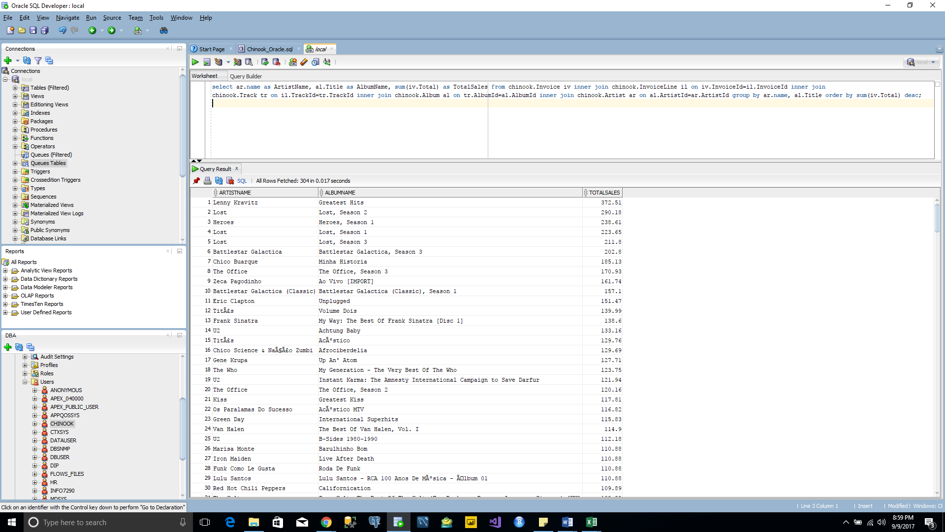

**Query 7:**

select CONCAT (emp.firstname || ' ',emp.lastname) as EmployeeName, sum(inv.Total) as TotalSales from Chinook.Invoice inv inner join Chinook.Customer cus on inv.CustomerId=cus.CustomerId inner join Chinook.Employee emp on cus.SupportRepId=emp.EmployeeId group by CONCAT (emp.firstname || ' ',emp.lastname) order by sum(inv.Total) desc;

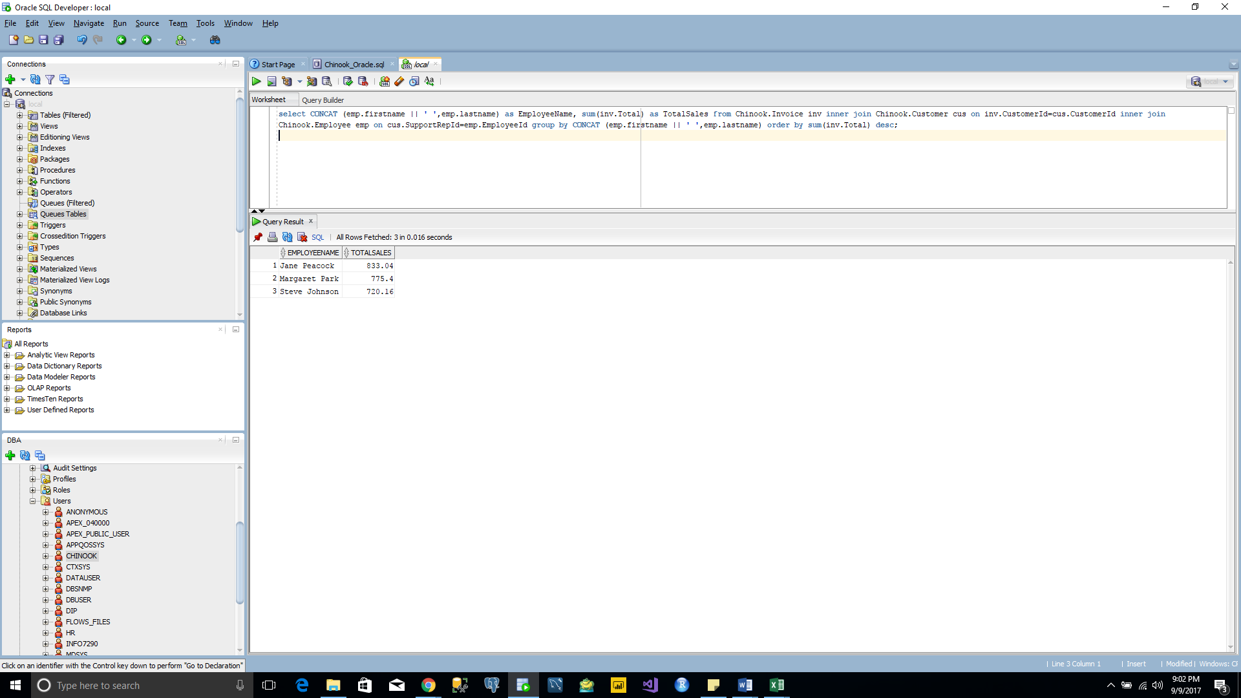

**Query 8:**

select m.name as MediaTypeName, count(t.trackid) as TrackBought, sum(t.UnitPrice) as Cost from Chinook.MediaType m inner join Chinook.Track t on m.MediaTypeId=t.MediaTypeId group by m.name;

